|  |  |  |  |  |
| --- | --- | --- | --- | --- |
|  | |  |  | **Sulzer Pumpen (Deutschland) GmbH** |
|  |  | Ernst-Blickle-Str. 29 |
|  |  | D-76646 Bruchsal, Germany |
|  |  | Phone +49 (0)7251 76-0 |
|  |  | Fax +49 (0)7251 76-401 |
|  |  | www.sulzer.com |
|  |  |  |
|  |  |  |  |  |
|  |  |  |  |  |
| L&T Technology Services Limited_4 | | Handled by |  | Sulzer Admin |
| Miss.Sulzer Admin | | Phone direct |  |  |
| 106/B | | E-Mail direct |  |  |
| 390021 | | Date |  | 18/02/2019 |
|  |  |  |  |  |
| India |  |  |  |  |
|  |  |  |  |  |
|  |  |  |  |  |
| Project: | Retrofit | | | |
| Customers Reference: | re | | | |
| SULZER-Reference: | SulzerReference | | | |
| TenderId: | T2 | | | |

Dear Miss Shelana Manoj,

Thank you very much for your enquiry.

We herewith submit our proposal for an OHX Upgrade Kit, including Casing Cover, Bearing Housing and Shaft. With this Upgrade, expensive piping adaptation will be avoided by keeping existing pump casing. Also the pump performance will not change due to reusing the existing impeller. In parallel, the modification allows for the installation of the newest mechanical seal design as per API 682. Furthermore, the bearing design follows API 610 rules and the OHX Upgrade Kit design helps to standardize spares.

The following pages and attachments describe our scope of supply in detail, including technical description and prices.

We trust this quotation meets with your expectations and look forward to a successful cooperation. Should you have any questions or comments, please do not hesitate to contact the undersigned.

Yours sincerely

SULZER Pumpen (Deutschland) GmbH

|  |
| --- |
| Sulzer Admin  Admin |

**Upgrade Kit**



Pump with OHX Upgrade Kit (execution with fan cooling)

**Design Benefits:**

* Extra heavy duty large diameter shaft Increased stiffness of rotor at seal chamber; better L3/D4 ratio for better seal and bearing life
* Larger radial and thrust bearings with higher load capacities
* Improved bearing lubrication and cooling by outboard fan
* Bearing housing isolators
* Ease of maintenance
* CW and CCW rotation
* Seal chamber sized to accommodate all single and dual cartridge seal configurations. Complies fully with API 682.
* Standardized spare parts
* The OHX Upgrade Kit utilizes many of the components and design features from the state-of-the-art API 610 Sulzer OHH end suction process pump.
* Latest Specifications
* More economical when compared to replacing complete pump skid (no modifications necessary to existing skid/piping/motor etc.)
* Better lead time vs new equipment and less process down-time

**Scope of supply and budget price**

**OHX Upgrade Kit**

The OHX Upgrade Kit consists of a heavy-duty standard bearing frame and an individually engineered shaft and casing cover.

**Design Features:**

* OHX Upgrade Kit will be customized to fit existing pump unit
* Fully complies with ISO 13709 (API 610 latest edition)
* Seal Chamber conforms to API 682
* Material Class S-6 mod.

**OHX Upgrade Kit (assembled) including:**

1 off Casing Cover 161.118------

1 off back Impeller stationary ring 502.203 (if applicable) ------

1 off Bearing Housing 330.302 size  ------

1 off Shaft 210.360 with shaft seal diameter 2mm ------

1 off Impeller Nut

1 off Gasket 400.115

1 Set of Bearings 320.304, 320.305

1 Set of Bearing Isolator 426.321, 426.322 (Vendor: PROTECH)

1 off Fan 831.381

1 Set of Operating Manual (electronic in PDF format, documentation in applicable

language) incl. sectional drawing with parts list, recommended spare

parts lists, general arrangement drawing with outline dimensions for scope of

supply including distance between shaft ends and connections

Incl. Engineering, Sulzer standard Painting and Packing (for standard shipping)

**Cross Section**

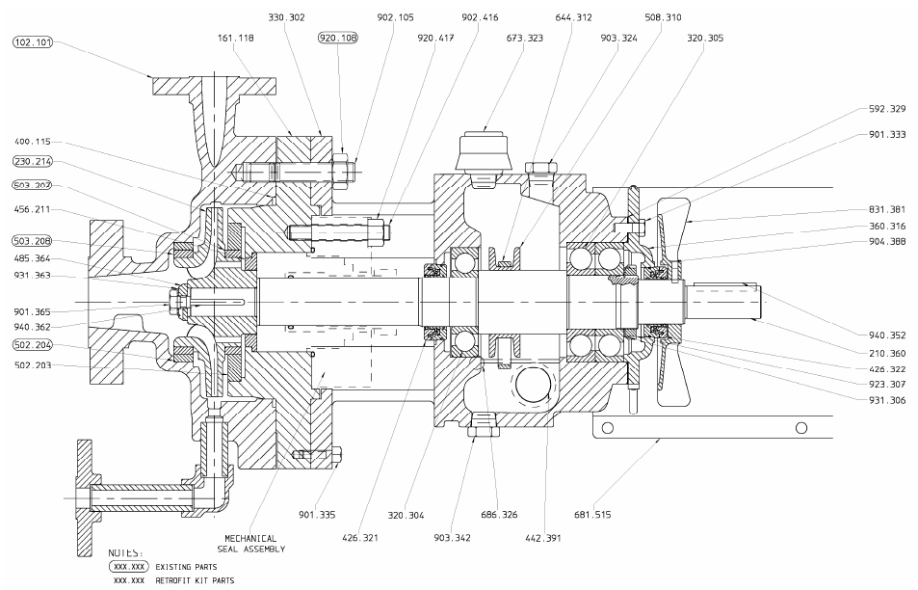

**Bill of Material**

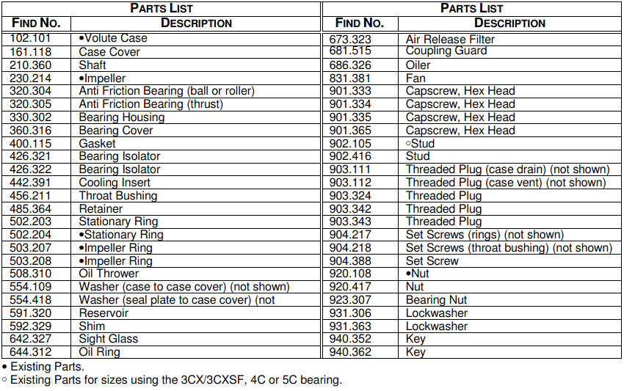

1 off coupling guard which is mounted on to the pump’s bearing housing by 4 hexagon screws. On the opposite (motor) side the coupling guard has a flexible extension whose position is being adapted towards the driver.

Key Features:
• Ambient temperature: -50°C... + 55°C
• Material: Aluminium
• Non-sparking design
• Allowable access dimensions and openings as per ISO 14120, EN 953 or ANSI/ AMT 815.1.
• Non painted
• Without window ---IMAGE---

1 off ATEX certification for the OHX Upgrade Kit. Support for complete pump ATEX certification can be given upon request.

1 off NACE conformity for the materials is limited to the scope of this quotation. Support for complete pump of NACE conformity can be given upon request.

**BUDGET PRICE for 1 Kits:** **EUR**

**weeks**

**General Remarks**

• Our quotation is valid only for the information and specifications that we received so far.

• Delivery time adders as well as price adders might apply, provided that changes, based on such additional information or specifications, can be performed.

• Additional material/quality tests and certificates are available against price adders.

• Scope of Supply shall be subject to changes for the purpose of incorporating the latest technical innovations.

• No workshop drawings will be furnished.

• Anything not mentioned in the commercial part and attached technical specification sheet is excluded; this refers to but is not limited to equipment, technical services, quality documents, tests, etc.

• Volute casing needs to be cleaned for Measurement.

• The repair work scope will provided from our local service center.

• This quotation do not consider any degradation or wear of re-used parts (i.e. impeller, volute casing…) that might have occurred over time

• This offer might be subject to additional price after inspection of the equipment and review by engineering

**Not in scope of supply:**

• Baseplate

• Motor

• Special Tools

• Pressure Test / Test Run, can be offered upon request

• Pump Volute Casing and Impeller

• Nuts and bolting

• Repairs

• Installation of OHX Upgrade Kit into volute casing and erection of seal support system at site, can be offered upon request

• Seal System piping, can be offered upon request

• Oil filling

We are happy to offer above listed excluded scope upon request.

**Commercial Conditions**

|  |  |
| --- | --- |
| **Pricing** | EXW Sulzer factory (acc. Incoterms 2010); packed , without VAT. |
| **Terms of Payment** | Payments shall be made at SULZER’s domicile, without any deduction for cash discount, expenses, taxes, levies, fees, duties and the like. Payments are due within 30 days after invoice date.  100 % upon delivery or notification of readiness for dispatch  Purchaser may be required to execute and deliver to SULZER an adequate payment security, if deemed to be necessary. |
|  |  |
| **Validity of Offer** | Quotation have a validity period of  days. Our offer is an indication only, without engagement on part of SULZER and is issued for budgetary purposes only. After clarification of technical, commercial as well as quality requirements, SULZER will issue a firm offer on request of your company. |
|  |  |
| **Delivery Time** | Based on our current workshop loading along with the quoted lead times by our sub-contractors we estimate that we could complete delivery within  weeks ex-works. If this does not meet your schedule we would be pleased to investigate possible improvements. |
|  |  |
| **Warranty** | SULZER warrants that the Supply will be of the kind and quality as described in the quotation and will be free of defects in workmanship and material.  The warranty period shall be twelve (12) months after commissioning; however, it shall end not later than eighteen (18) months after notification that the Supplies are ready for dispatch.  Parts subject to normal wear and tear as well as damages caused by incorrect storage, handling and maintenance are excluded from our warranty. |
| **Documentation** | Documentation according to SULZER standard in English language. Operating and Instruction Manuals according to EU directive. |
|  |  |
| **Further Conditions** | The Standard terms and conditions of SULZER which apply to this offer can be found on: www.sulzer.com |